AI StudyBuddy – Project Documentation
Team Details
Project Title:AI StudyBuddy
Team ID: SWTID-2026-7436
Team Leader:
Dhanushree G
Email id:24bsccs47@cttewc.edu.in

Team Members:
Keerthika K
Email id:24bsccs52@cttewc.edu.in

Pavithra U
Email id:24bsccs14@cttewc.edu.in

Dhanalakshmi C
Email id:24bsccs01@cttewc.edu.in

Description
AI StudyBuddy – AI Assistant for Smarter Learning and Study Support
AI StudyBuddy is an AI-powered learning assistance platform developed by our team to simplify and accelerate the study process for students by leveraging modern web technologies and Generative AI. The application provides an intelligent backend system that enables students to upload study materials, generate concise summaries, create flashcards, produce quizzes, and receive personalized study plans through AI-generated responses.
The backend is developed using Node.js and Express.js, following a RESTful API architecture that ensures scalability, maintainability, and secure communication between frontend and backend services. MongoDB serves as the primary NoSQL database, while Mongoose ODM provides schema validation, data modeling, and efficient database interactions.

Tech Stack
- Runtime & Server Framework: Node.js, Express.js
- Database & ODM: MongoDB, Mongoose ODM
- Generative AI Engine: Google Gemini API (gemini-2.5-flash via @google/generative-ai)
- Security & Auth: JSON Web Tokens (JWT), bcryptjs password encryption, Role-Based Access Control (RBAC)
- File Processing: multer file upload middleware
Problem Statement & System Solution

Key Challenges
- Time Inefficiency: Students spend excessive time manually summarizing lengthy lecture notes and reading materials.
- Repetitive Preparation: Creating revision flashcards and practice questions manually is labor-intensive.
- Unstructured Scheduling: Difficulty building actionable study plans based on exam dates and available daily study hours.
- Dispersed Tools: Loss of focus when switching between separate applications for note-taking, testing, and scheduling.

Platform Solution
- Centralized API Suite: Offers a single backend service managing authentication, file uploads, AI content generation, and resource persistence.
- AI Processing Pipeline: Communicates dynamically with the Google Gemini API to transform study content into structured JSON datasets (flashcards, quizzes, study plans).
- Secure Resource Storage: Persists all generated study materials in MongoDB associated with user accounts for continuous revision.

System Architecture
The application follows a decoupled, layered RESTful architecture separating routing, security middleware, business controllers, database models, and external AI integrations.

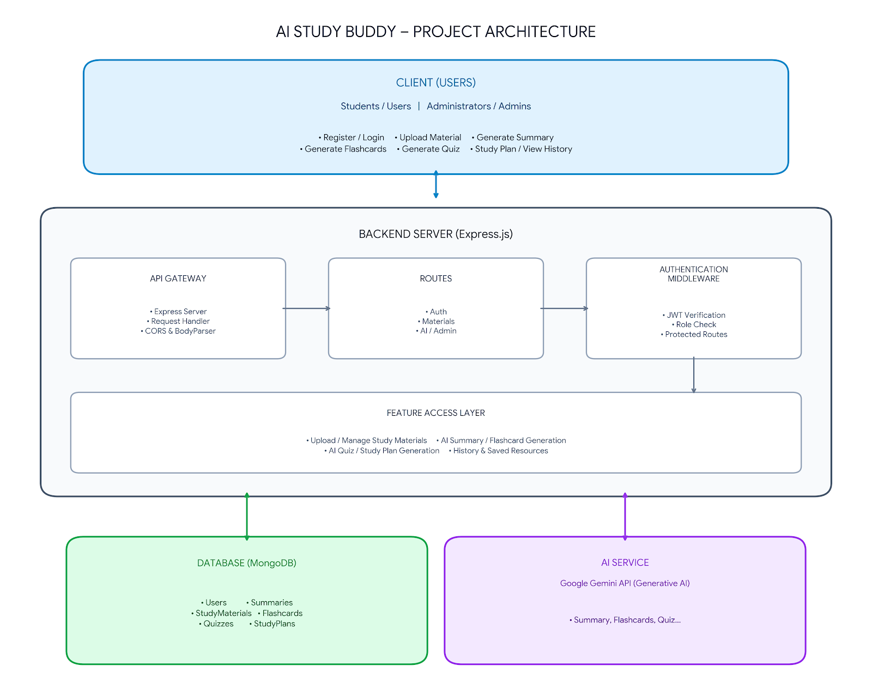

Architecture Components
- Client Application: Allows users to register, authenticate, upload study materials, and invoke AI generation services via RESTful HTTP endpoints.
- Express Server: Express.js processes inbound HTTP requests, handles routing, executes middleware chains, and formats JSON responses.
- Authentication Middleware: Validates JWT access tokens in the Authorization header (Bearer <token>), protects private routes, and enforces role restrictions (adminOnly).
- Route Handlers: Separates endpoints across auth (/api/auth), material management and AI features (/api/materials), and administrative operations (/api/admin).
- AI Service Layer: A utility module (gemini.js) communicating directly with Google's @google/generative-ai SDK (gemini-2.5-flash).
- Database Layer: MongoDB and Mongoose ODM handling schema enforcement, persistence, and data relationships.

Entity-Relationship (ER) Diagram Description
In our application's database design, data is structured around two core MongoDB collections: Users and Materials, with AI outputs stored directly within the Material document schema for optimal read/write efficiency.
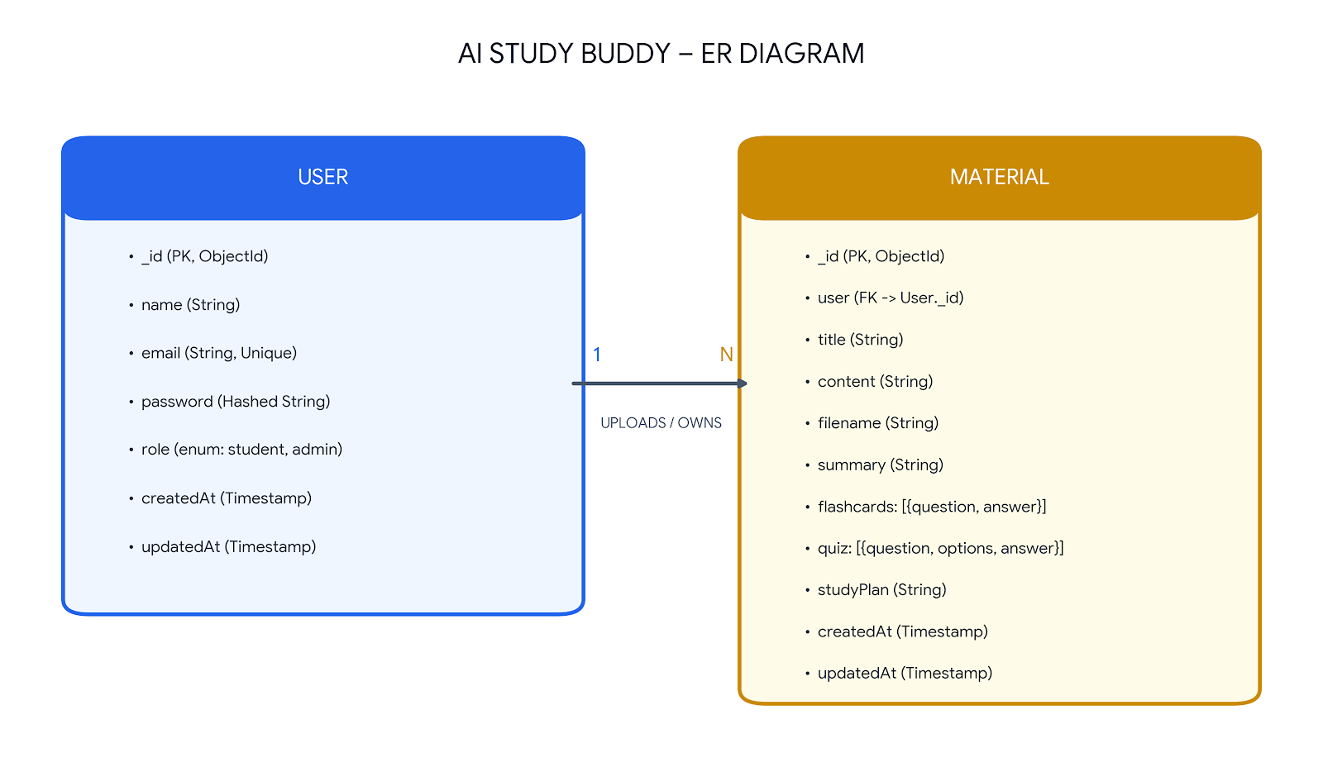

Project Setup and Configuration

Project Initialization
Initialize the Node.js project and install required dependencies:
Bash
npm init -y
npm install express mongoose bcryptjs jsonwebtoken cors dotenv multer @google/genai express-async-errors
npm install --save-dev nodemon

Directory Structure
Plaintext
AI-STUDYBUDDY/
├── src/
│ ├── controllers/
│ │ ├── adminController.js
│ │ ├── authController.js
│ │ └── materialController.js
│ ├── middleware/
│ │ ├── auth.js
│ │ └── upload.js
│ ├── models/
│ │ ├── Material.js
│ │ └── User.js
│ ├── routes/
│ │ ├── admin.js
│ │ ├── auth.js
│ │ └── materials.js
│ └── utils/
│ ├── db.js
│ ├── gemini.js
│ └── tokens.js
├── uploads/
├── .env
├── index.js
├── package-lock.json
└── package.json

System Demonstration

User Authentication Testing

1. User Registration (POST /api/auth/register)
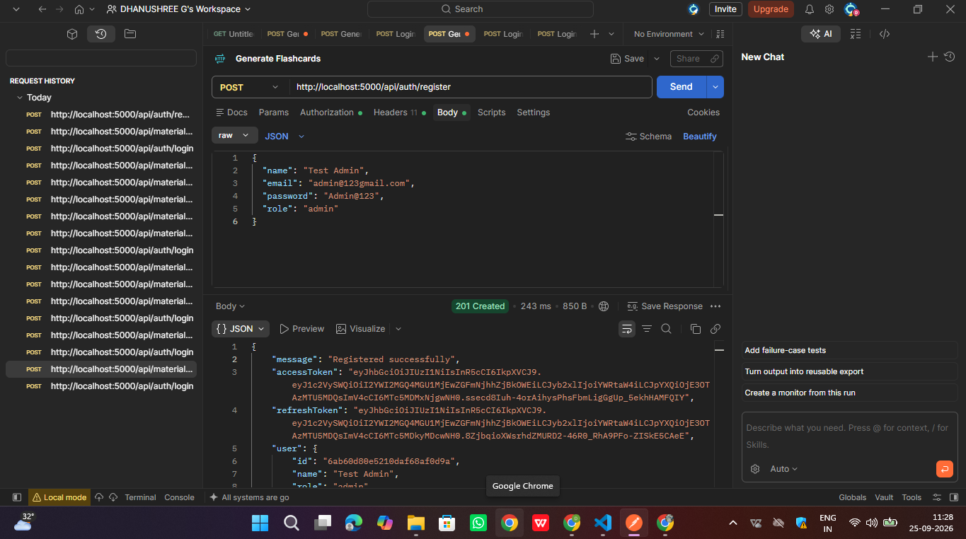

Postman execution showing user registration endpoint returning 201 Created with access/refresh tokens and user details.
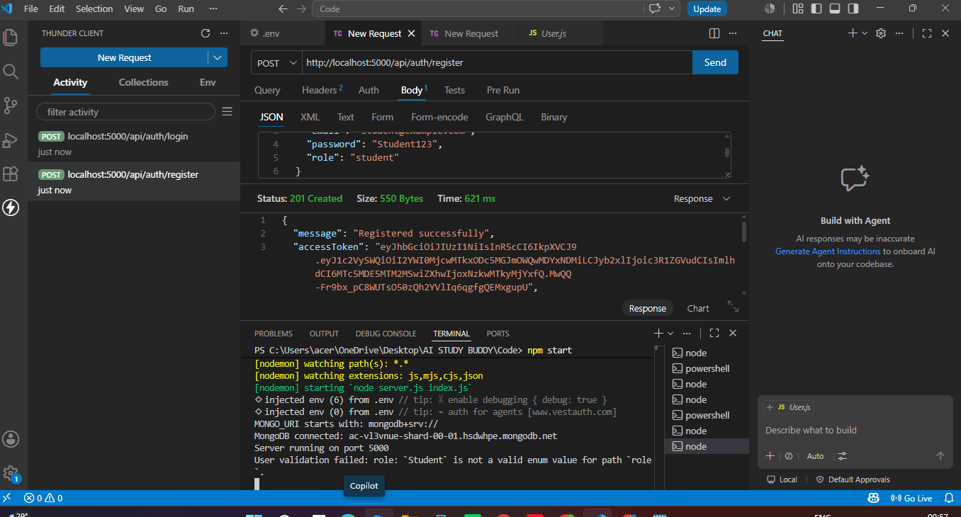
VS Code Thunder Client execution verifying registration route with active server logs.

2. User Login (POST /api/auth/login)
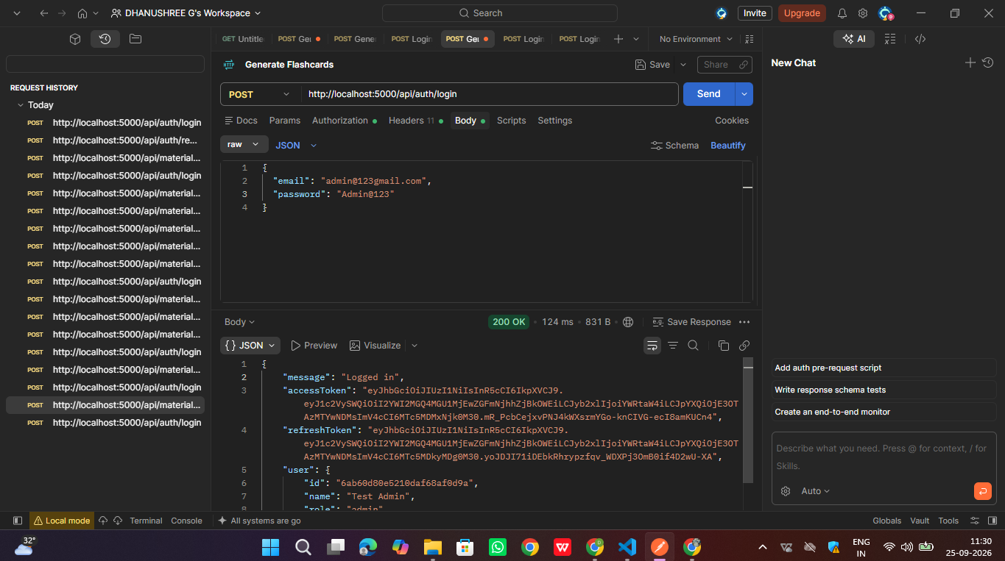
User authentication execution returning JWT bearer token.
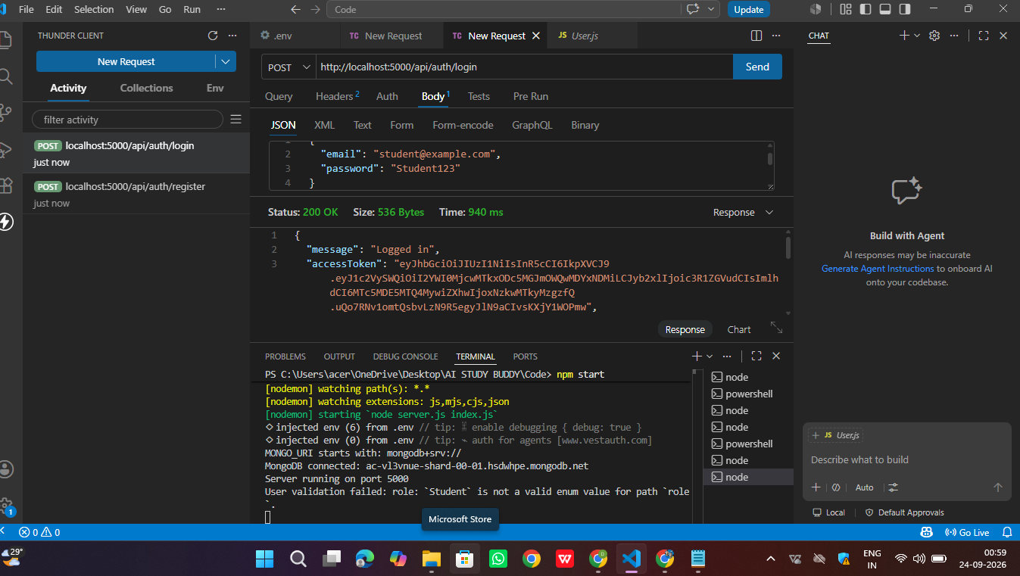
VS Code Thunder Client execution showing successful login response (200 OK) and JWT access token.

3. Upload Study Material (POST /api/materials/upload)

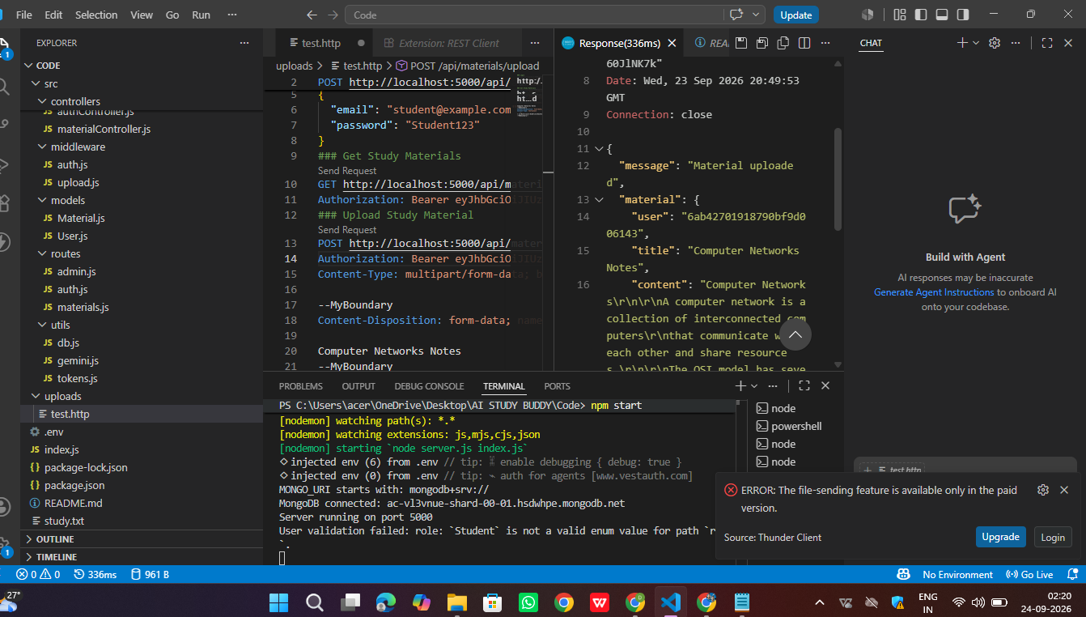
REST Client execution uploading study document (study.txt) and returning created material record.
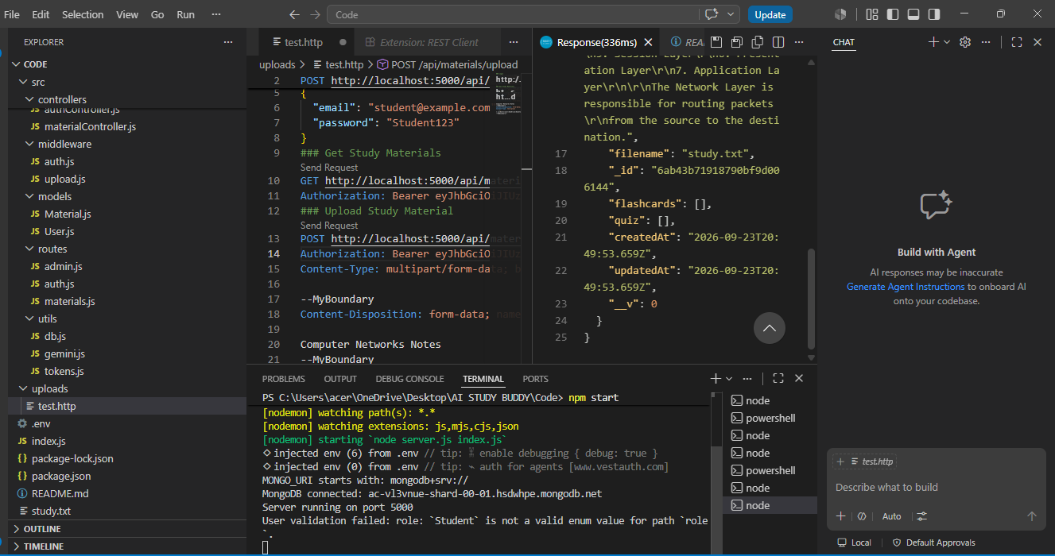
REST Client response details showing stored material metadata, file reference, and empty feature arrays.
4. AI Summarize Material (POST /api/materials/:id/summarize)
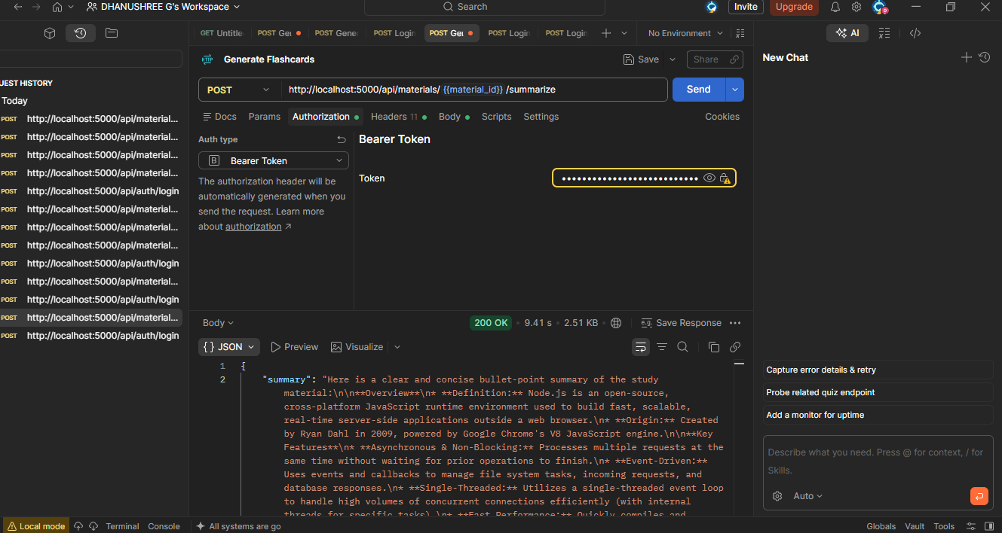AI Summary Generation response returning structured bullet points from study text.

5. AI Flashcards Generation (POST /api/materials/:id/flashcards)
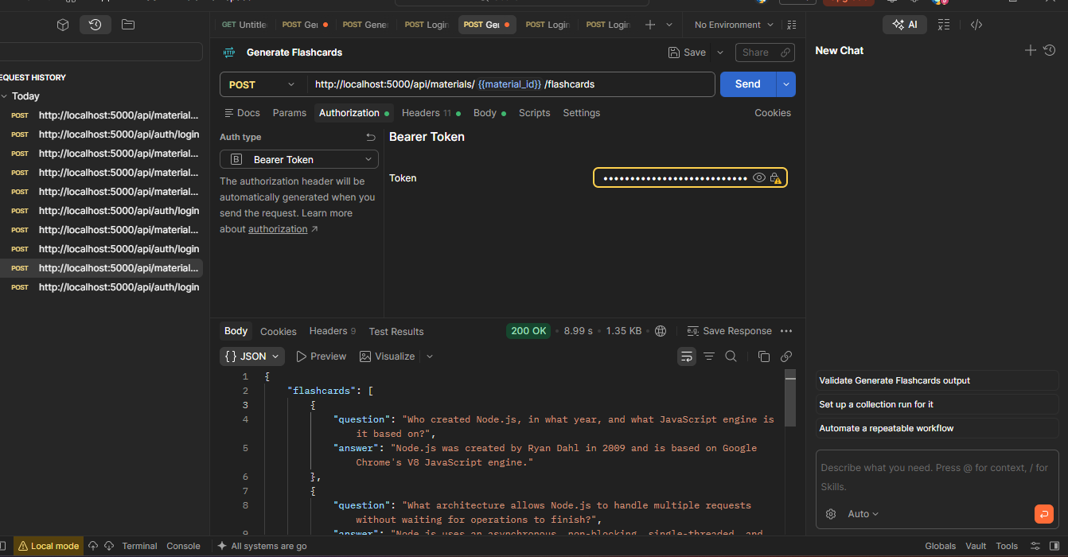
AI Flashcard Generation response returning structured active recall Q&A pairs.
6. AI Quiz Generation (POST /api/materials/:id/quiz)
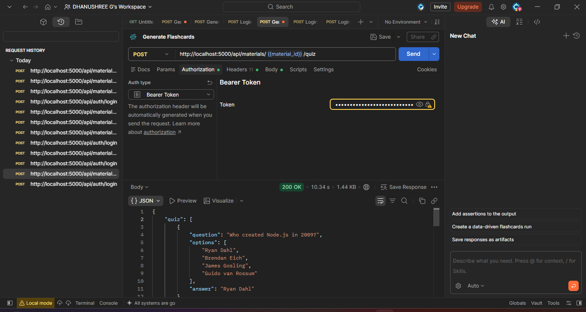
AI Quiz Generation response returning 4-option multiple choice questions.

7. AI Study Plan Generation (POST /api/materials/:id/study-plan)
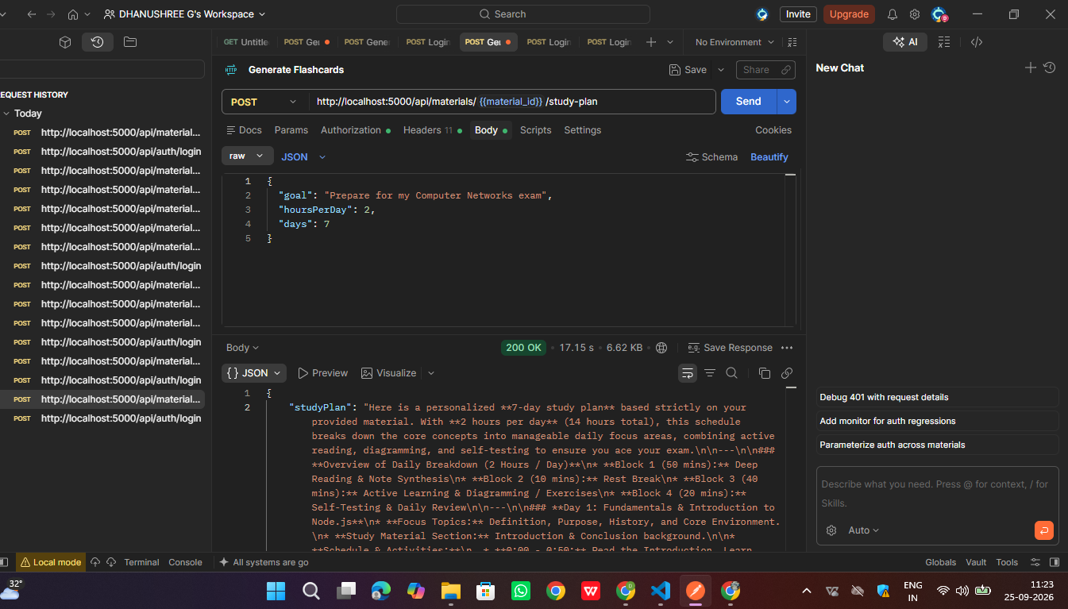
AI Study Plan Generation response returning a customized multi-day study schedule.

8. Admin Get Registered Users (GET /api/admin/users)
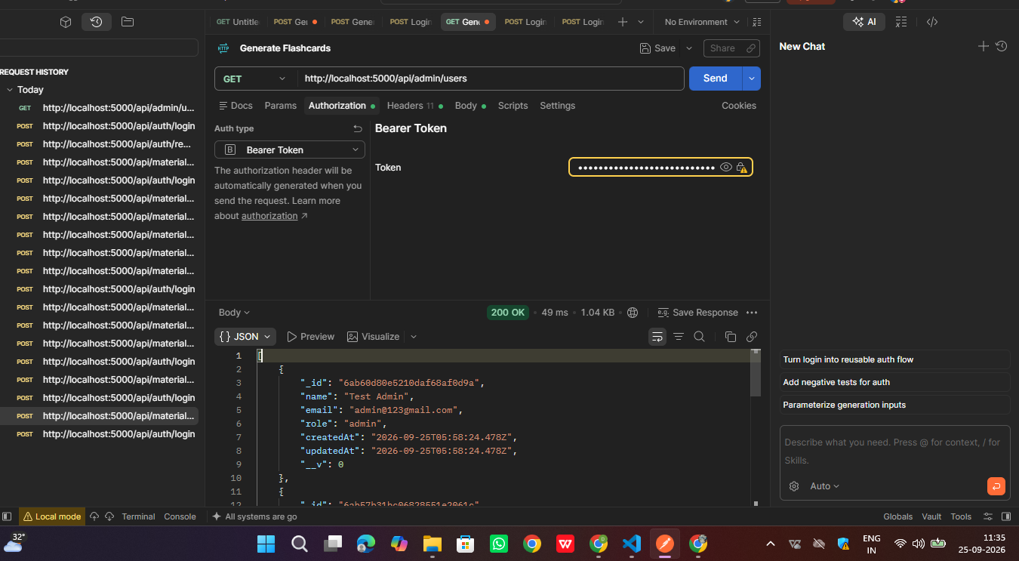Admin endpoint execution fetching user account details in Postman.

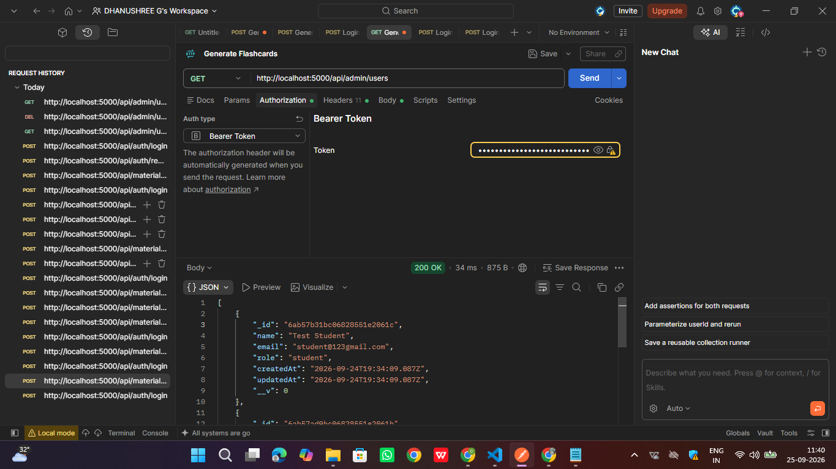
Admin endpoint response displaying list of registered student accounts.

9. Admin Delete User & Material (DELETE /api/admin/users/:id)
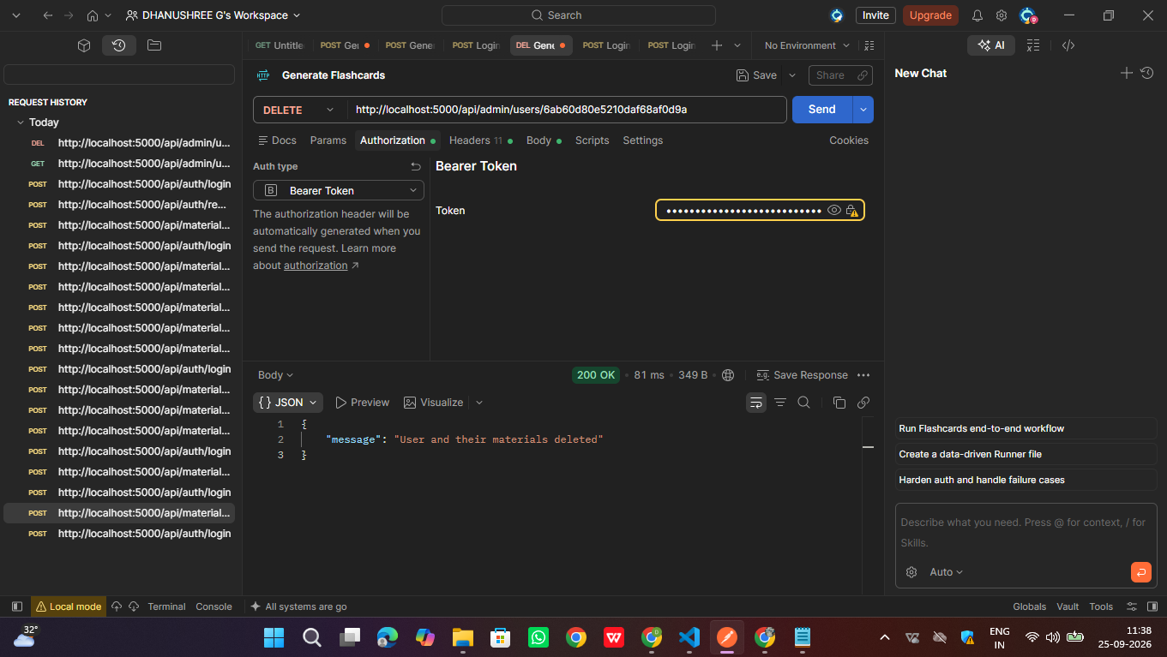Admin DELETE endpoint execution removing a target user and associated uploaded materials

Demo video link:
https://drive.google.com/file/d/1wON5c4hN2l_y8NkrNI09p3hfq05qOFs_/view?usp=drivesdk

